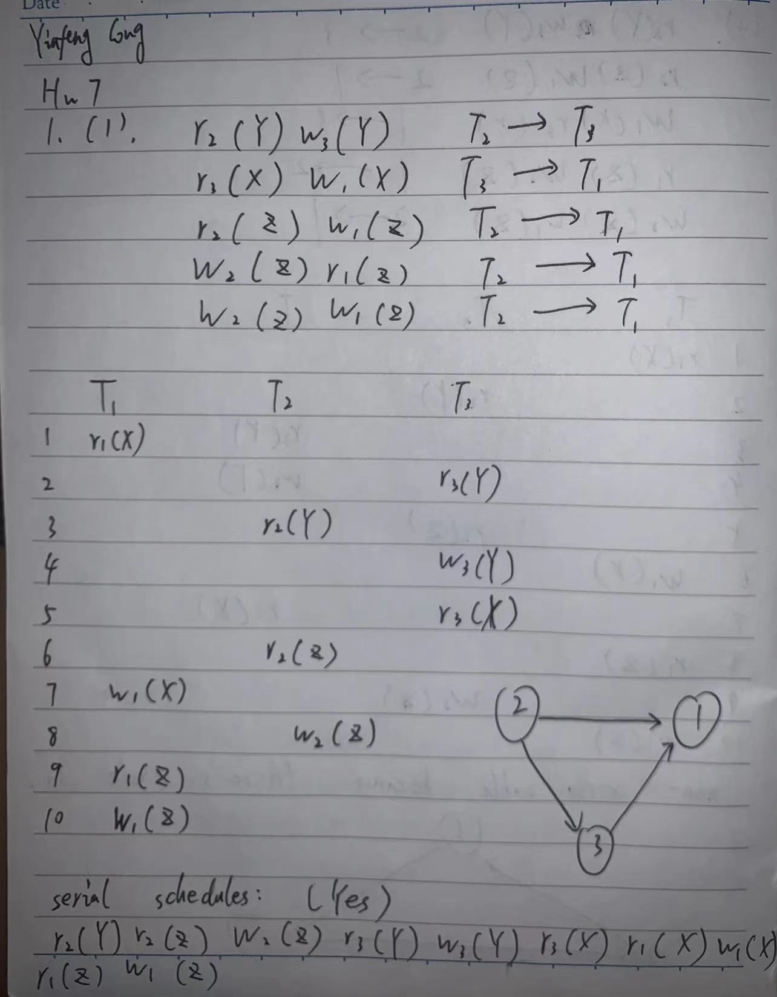

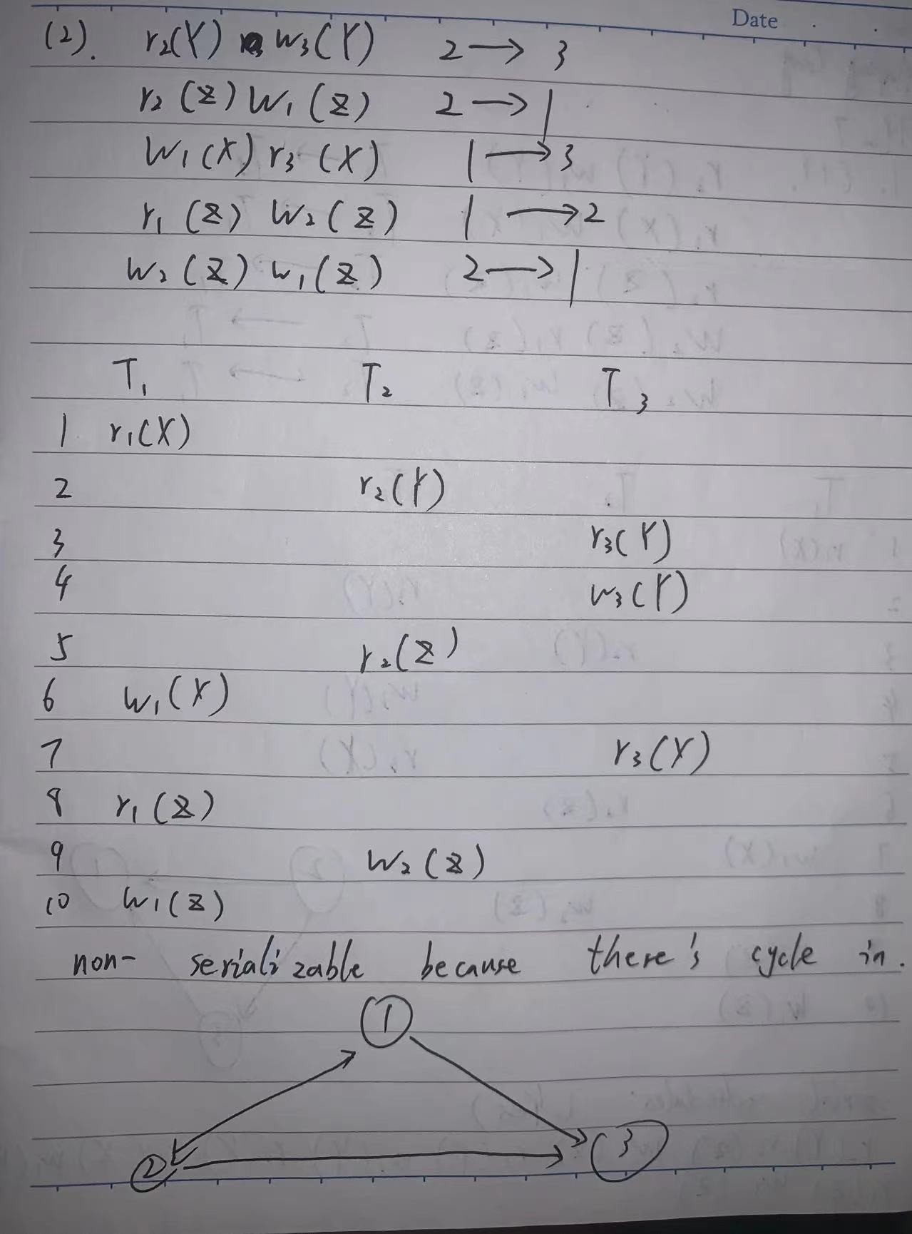

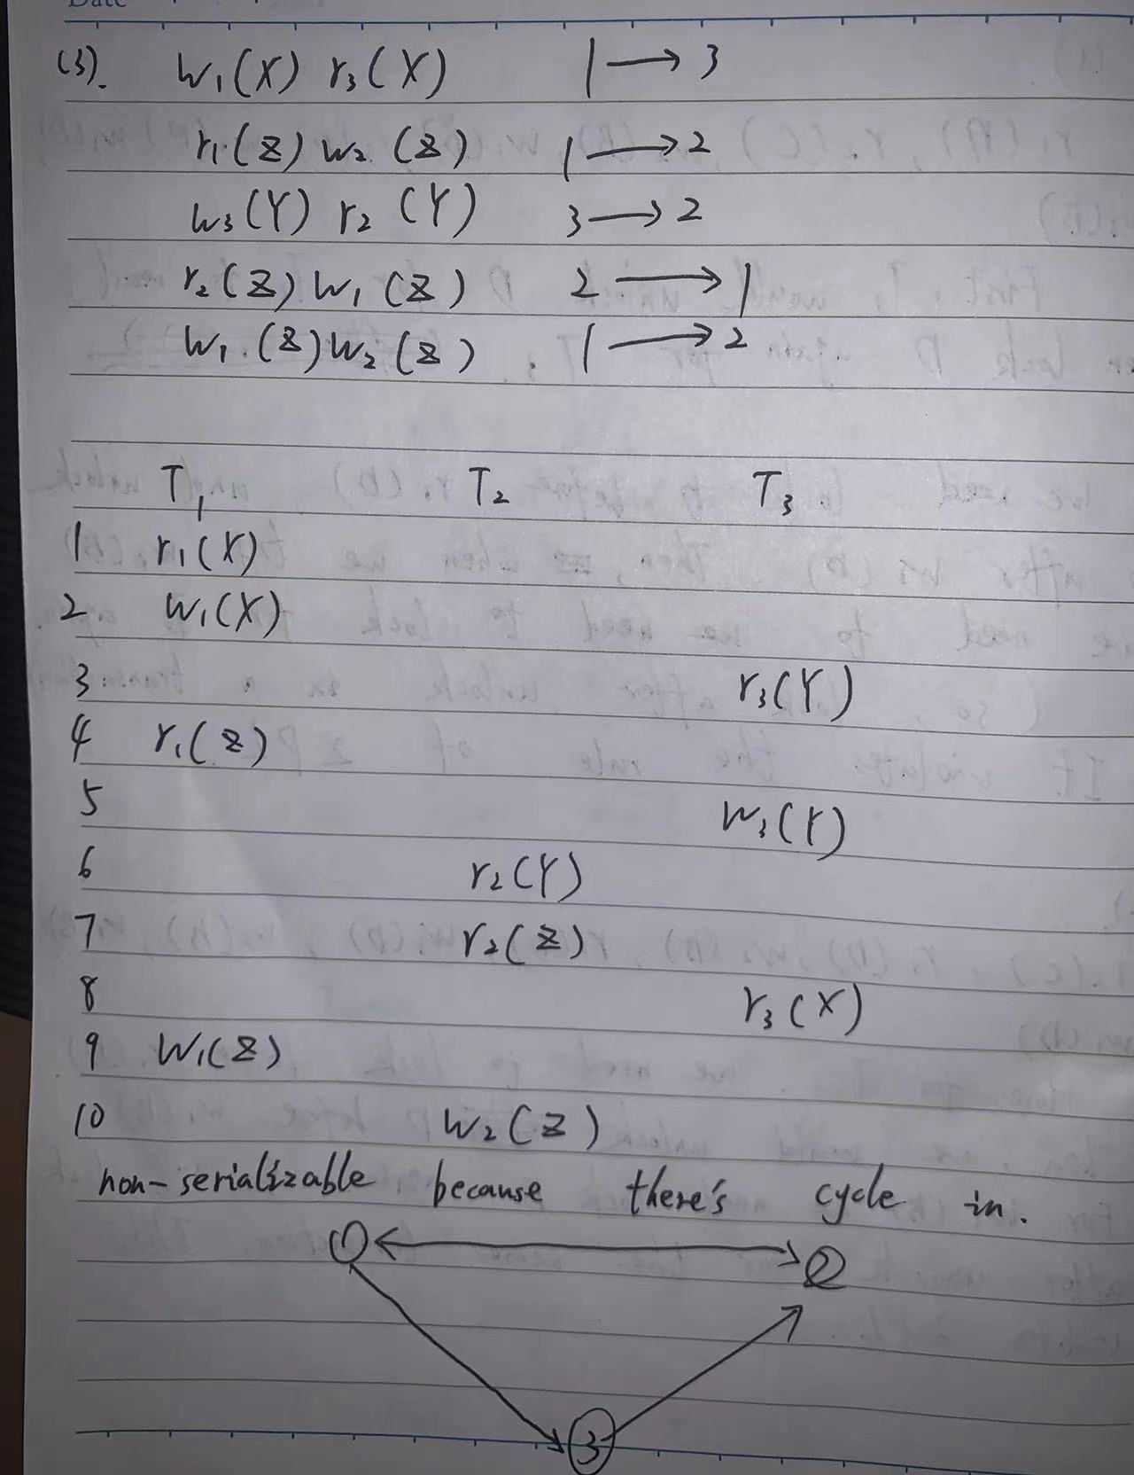

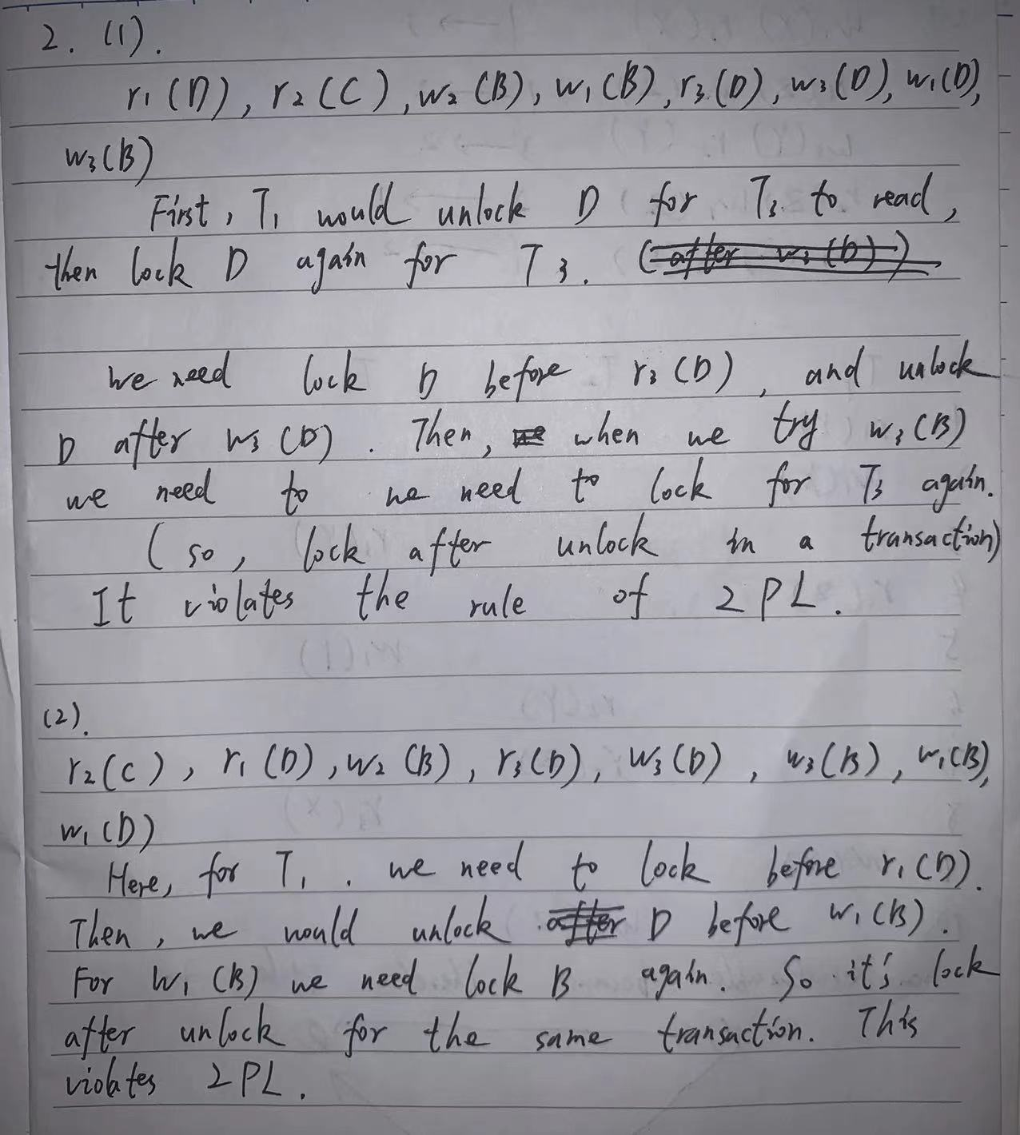

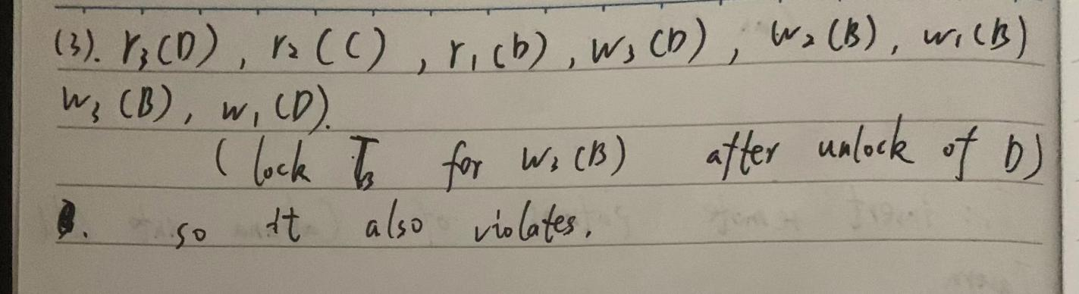

Patrons of each bar:

Cabana: Nothing left

Old Tavern: remote patrons from Cabana (B)

New Tavern: local patrons from Old Tavern and remote patrons from New Tavern (C and D)

No, Local patrons from Cabana are LOST, they do not make it to Old Tavern. Both of local and remote patrons of Old Tavern make it into New Tavern.